Light Source

📘 Definition
# Source: AI Source: Provided by: [Data Path: Persons Table -> ID Column: 1, Name_En Column: Motasem Essam] -> From: [ChatGPT] on [5/2/2026]
A light source is anything that produces light so that objects can be seen. In both real life and computer graphics, it is what “shines” light onto objects and makes them visible.

💡 Types of light sources
# Source: AI Source: Provided by: [Data Path: Persons Table -> ID Column: 1, Name_En Column: Motasem Essam] -> From: [ChatGPT] on [5/2/2026]
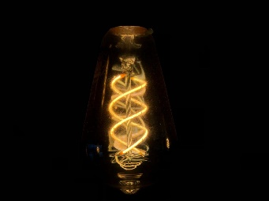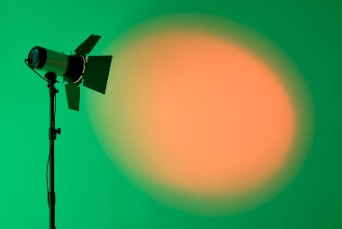
Common examples include:
- ☀️ Sun → natural light source
- 💡 Light bulb → artificial light source
- 🔦 Flashlight / spotlight → directional light source
- 🕯️ Candle → small warm light source

🧠 How it works in graphics
# Source: AI Source: Provided by: [Data Path: Persons Table -> ID Column: 1, Name_En Column: Motasem Essam] -> From: [ChatGPT] on [5/2/2026]
In computer graphics, a light source is a virtual object that simulates real light. It helps decide:
- Where light comes from
- How bright objects appear
- Where shadows are created
- How realistic a scene looks

🎮 Types in computer graphics
# Source: AI Source: Provided by: [Data Path: Persons Table -> ID Column: 1, Name_En Column: Motasem Essam] -> From: [ChatGPT] on [5/2/2026]
- Point Light → shines in all directions (like a bulb)
- Directional Light → parallel light rays (like sunlight)
- Spot Light → cone-shaped beam (like a torch)
- Ambient Light → soft general lighting everywhere

🚀 In short:
# Source: AI Source: Provided by: [Data Path: Persons Table -> ID Column: 1, Name_En Column: Motasem Essam] -> From: [ChatGPT] on [5/2/2026]
Light source = anything (real or digital) that produces light and makes objects visible.

